**Git's Three-Stage Model**

Git operates on a three-stage model, which includes:

1. **Working Directory:**
   * This is where you directly interact with your files.
   * You edit, create, and delete files here.
2. **Staging Area (Index):**
   * A temporary holding area for files you've marked for inclusion in your next commit.
   * You use git add to stage changes.
3. **Local Repository:**
   * A database that stores the complete history of your project.
   * Each commit creates a snapshot of the entire project at that point in time.

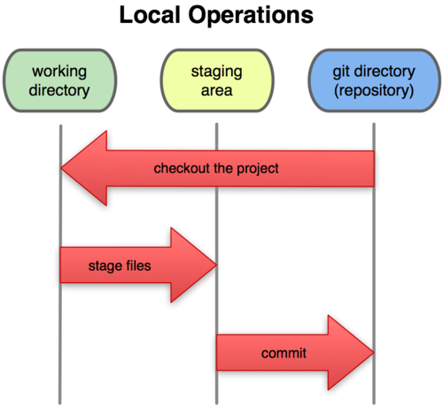

Git's ThreeStage Model

**Distributed Nature of Git**

Unlike centralized version control systems, Git is a distributed system. This means that each developer has a complete copy of the repository, including its entire history.

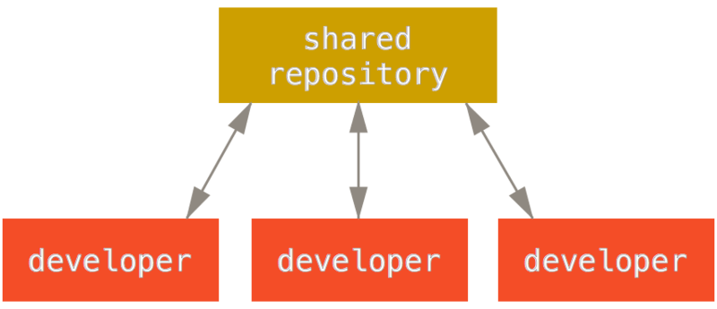

Git's Distributed Nature

**Key Git Operations**

* **Committing:**
  + Creates a snapshot of the current state of the project.
  + Stores the snapshot in the local repository.
* **Branching:**
  + Creates a new line of development.
  + Allows you to work on different features or bug fixes simultaneously.
* **Merging:**
  + Combines changes from different branches into a single branch.
* **Pushing:**
  + Sends local commits to a remote repository.
* **Pulling:**
  + Fetches commits from a remote repository and merges them into the local branch.

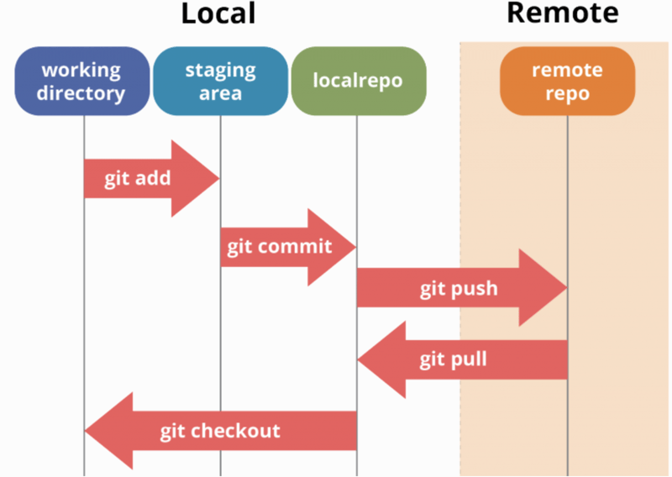Git's Basic Workflow

**Additional Concepts**

* **HEAD:** A pointer to the current branch or commit.
* **Remote Repository:** A copy of the repository hosted on a server.
* **Forking:** Creating a copy of a remote repository.
* **Pull Request:** A request to merge changes from one branch into another.